How create NAT port forwording rules
- Create Port forward Rule
1. Browse to firewall \ NAT .
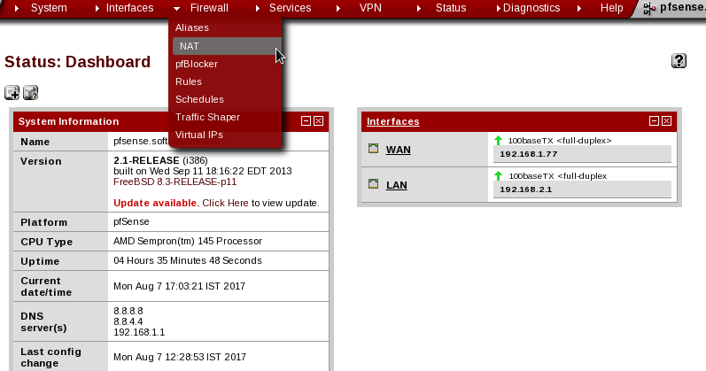
2. Select the port forwarding tab.
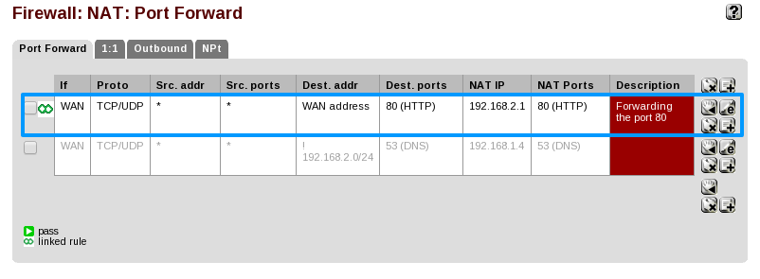
3. Click the plus button to create a new NAT port forward rule.
4. For destination port range, choose for the http from and to torp down box.
5. For Redirect the ip address is enter the internal ip address of network.
6. For redirect target port choose http.
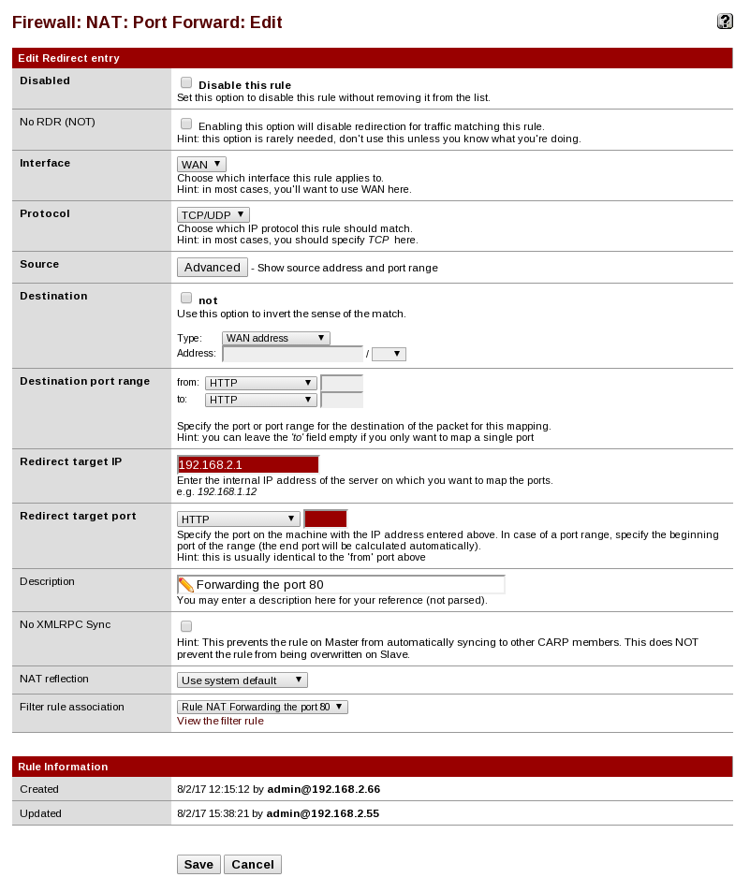
7.Save the changes & apply the changes.
Create NAT 1:1 Rule
1. Browse to firewall & choose virtuval Ips to create a alisa used for NAT 1:1 rule .
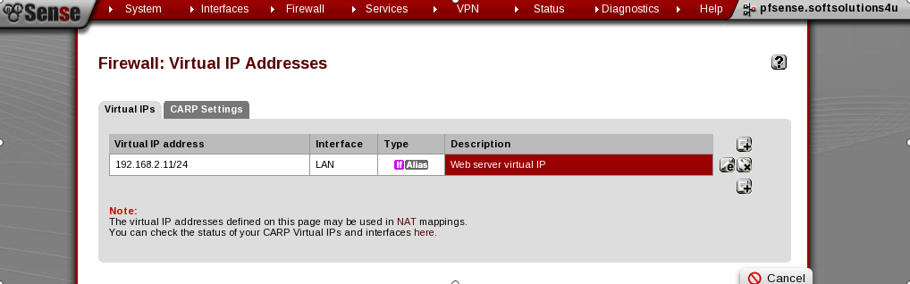
2.Browse to firewall \ NAT .

3. Select the NAT 1:1 tab.
4. Click the plus button to create a new NAT 1:1 rule.
5. For Interface, choose the WAN interface .

6. For External subnet IP is enter the WAN IP address of virtual IP.
7. For Internal IP is enter the LAN IP address of network.

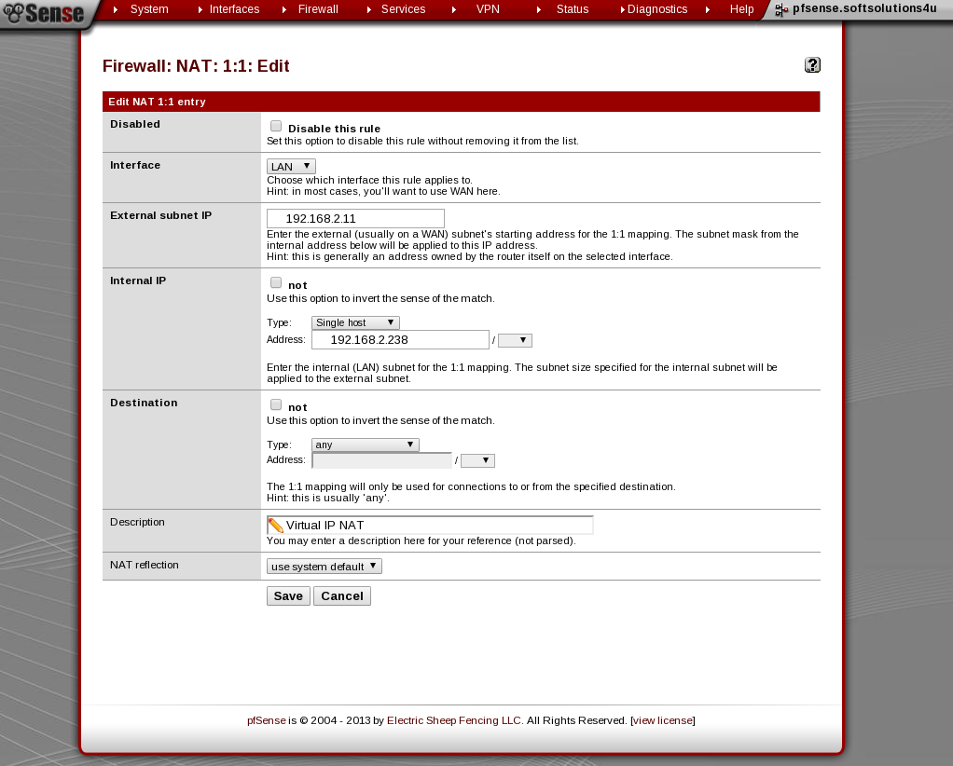
8.Save the changes & apply the changes.

Now we have access the our web browser of internal IP address(192.168.2.238). The web browser showing the web server of External IP address(192.168.2.11).

Create Outbound Rule
1. Browse to firewall \ NAT .
2. Select the outbound NAT tab.
3. Click the Default mode to create a automatic outbound NAT rule.
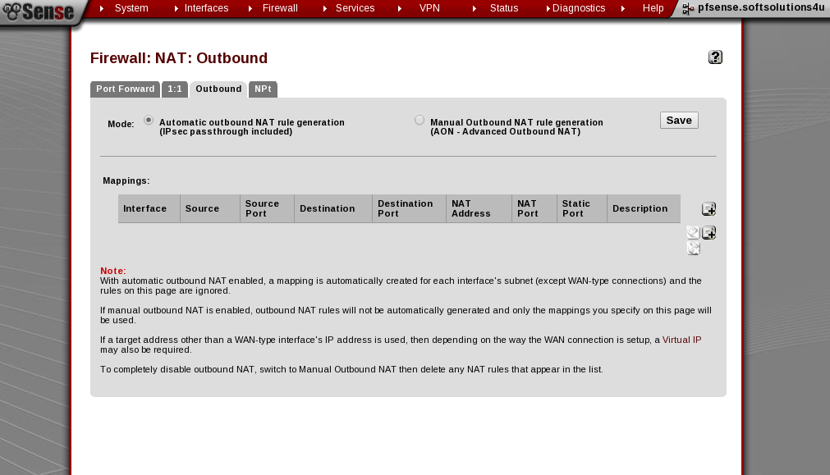
The default automatic outbound NAT rule is mapping the all the entire traffic of LAN and WAN network. to control the wich interae traffic will exit or not.

